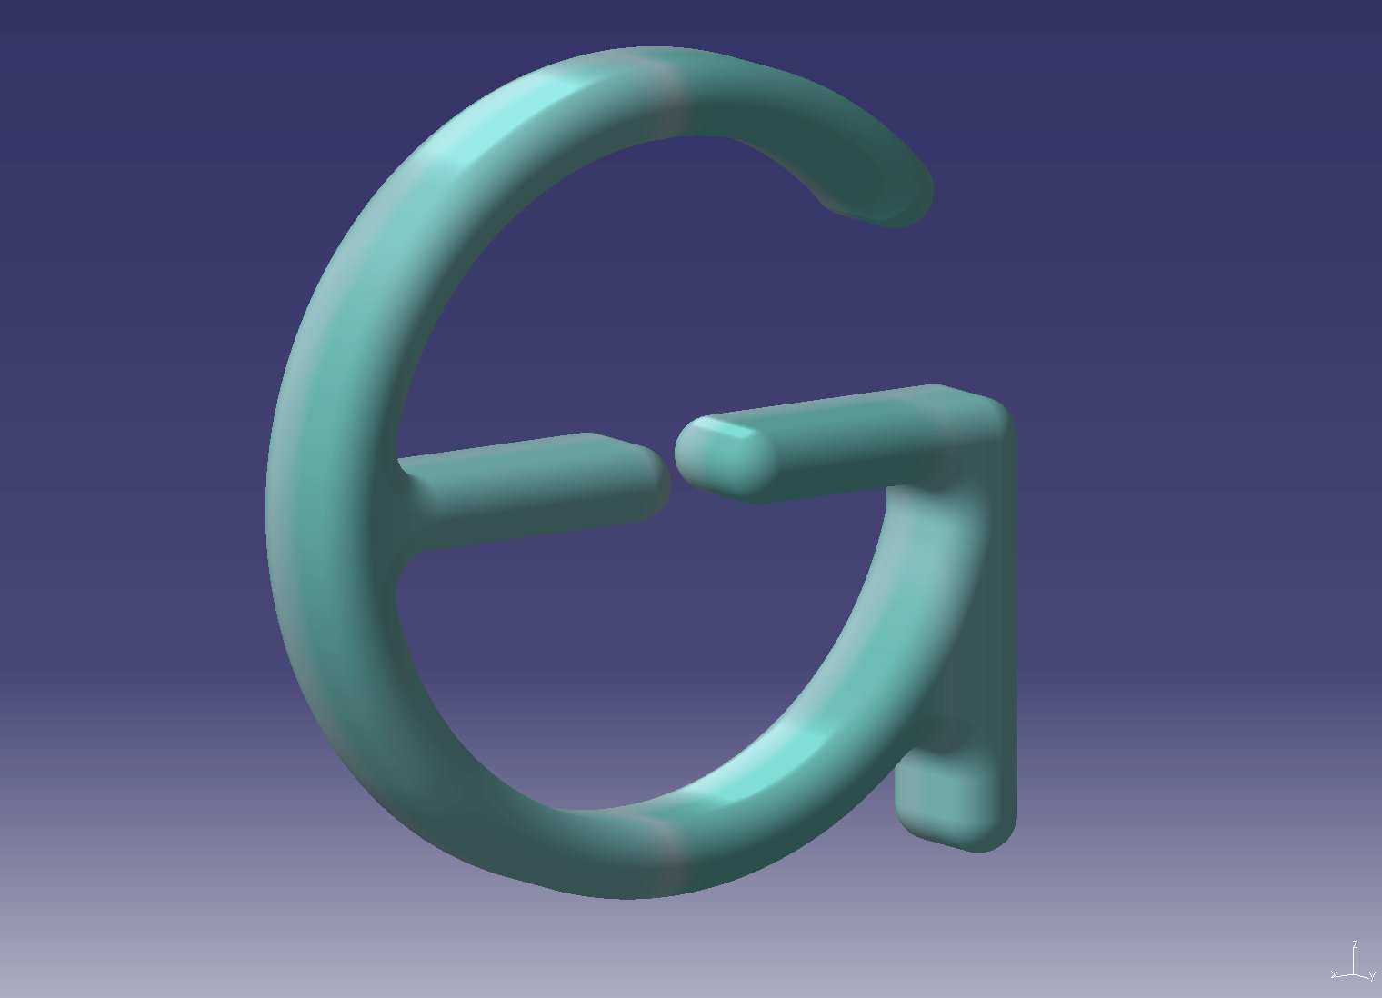
FS FlexModel-Documentation

The Problem

Due to the complex construction and the tight tolerances in submarines’ piping, most of the pipe spools (that is, more than 95% of the 6500-7500 pipe spools per boat) are fabricated iaw the template method.
Depending on the diameter and the complexity of the pipe spool, the pipefitter must visit the section/boat at least 3 to 4 times only for the template preparation.
Due to this, a lot of man-hours and time are consumed and a lot of working places on board are occupied only for the template preparation. Also, the achieved by this method accuracy is low and the level of stresses after installation is high.

The Template Preparation Method

We will study the process in three case studies:

- Pipe Spool of DN ≥ DN32, Presented in Isometric.
  - The pipefitter requests from the Bending Machine Operator (BMO) to bend the template (Pipe 10x1 mm) of the specific spool(s).
    - BMO transfers the bending data from Isometric to ISOBuilder, checks and sends the data to the CNC bending machine.
    - BMO bends the template (mild steel pipe 10x1) on one of the CNC bending machines (called Initial-Template).
  - The pipefitter transports the Initial-Template of the pipe spool on board the section/boat. He installs and makes manually the necessary modifications to it. It needs to be noted that only angular modifications are possible or the template needs to be splitted.
  - Back in the workshop, the pipefitter delivers the modified template for measuring and re-bending of pipe spool template.
    - BMO measures the modified spool template, transfers the data to IsoBuilder, checks the data and transfers them to the CNC Bending Machine.
    - BMO bends the New-Template.
  - With the New-Template in hand the pipefitter goes on board again in order to check that the New-Template fits on board. Some minor modifications may be needed and the process continues to Step c, or no modification required and the process continues to Step e.
  - Back in the workshop, the pipefitter asks from the BMO to bend the Real-Spool iaw the last bending data. It needs to be noted that not all lengths of the pipe ends are accurate.
    - BMO bends the Real-Spool (for example DN32).
  - This time the pipefitter moves on board with the Real-Spool in hand, in order to mark the exact position of the endpoints.
  - Back in the workshop, the worker cuts in-length the end lengths. The Final-Spool is now ready for the next Piping Process Phase, i.e. Welding or Strength Pressure Test.

- Spool with DN ≥ DN16, <DN32, Not Always Presented in Isometric.
  - The pipefitter visits the section/boat having in hand some notes and/or sketches and/or prints from the plastic-model or e-model and a 5mm Alum wire. The worker cuts and bends the wire in order to create the pipe spool template.
  - The process continues to 1.c

- Spool with DN <DN16, Not Presented in Isometric.
  - The pipefitter visits the section/boat having in hand some notes and/or sketches and/or prints from the plastic-model or e-model and a 5mm Alu wire. The worker cuts and bends the wire in order to create a template. A long complex template will be in more than one connected pieces of Alu wire.
  - Back in the workshop, the pipefitter bends manually the Real-Pipe, or delivers the template for measuring and CNC Bending of the Real-Pipe.
    - BMO measures the modified spool template, transfers the data to IsoBuilder, checks the data and transfers them to the CNC Bending Machines.
    - BMO bends the New-Template.
  - With the Real-Pipe in hand the pipefitter goes on board again in order to check that fits on board. Some minor modifications may be needed and the process continues to Step b, or no modification required and the process continues to Step d.
  - Back in the workshop, the pipefitter asks from the BMO to bend the Real-Spool iaw the last bending data. It needs to be noted that not all lengths of the pipe ends are accurate.
    - BMO bends the Real-Spool (for example DN12).
  - This time the pipefitter moves on board with the Real-Spool in hand, in order to mark the exact position of the endpoints.
  - Back in the workshop, the worker cuts in-length the end lengths. The Final-Spool is now ready for the next Piping Process Phase, i.e. Welding or Strength Pressure Test.

The Disadvantages of the Used Working Method

- The Scanner/ Measuring Arm and CNC Bending Machines are occupied/involved in the sub process “Template Preparation”. Extra Mhrs for data entry, measuring, bending required.
- Several (min 3-4 times) visits on board the section/boat required only for template preparation. Due to these, consumption of extra man-hours and occupation of working places occurs.
- The endpoints position is not defined on the template. Due to this it is not possible the cutting-in-length of the pipe row material before bending. This results to an extra visit on board with the real pipe (sometimes rather heavy) only for the accurate marking of the real pipe ends and then cut-in-length of the already bended pipe.
- The method’s geometrical accuracy is rather low which leads to
  - increased modifications,
  - increased number of visits on board and
  - finally stresses after installation.
- The method can be used only for spools without branches.
- The final (i.e. after welding) spool cannot be geometrically checked before transportation and installation on board.
- The pipe spool fabrication process cannot be separated into shop/board sub processes where specialized groups of pipefitters could produce more effective and in a better accuracy the pipe spools.
- The pipe spools grouping method cannot be used effectively. To produce a template, the adjacent real pipe spools are required to be already installed. Due to this we are forced to work either pipe spool by spool (in case of spools connected to a hydraulic block) or in layers (in case of pipe banks).
- The straight parts length cannot be modified (unless we split the template).
- The template cannot be measured while in place on board the section/boat.
- The template materials (Mild Steel Pipe 10x1mm and Alum 5mm Wire) cannot be re-used.

The Proposed Method

How to eliminate all these disadvantages? How to simplify and minimize the Consumed Mhrs, the Required Time and increase Accuracy/Quality for the above mentioned process?
Across the ages from the ancient world to the modern one, human potential has always been defined by our tools.
The right tools create new possibilities and give us limitless potential. Give an innovative mind a powerful new tool, and there is no limit to what can be accomplished.
FreeSoft Engineering has developed a concept/product/method/tool which answers the above mentioned questions.
The “FS FlexModel” is a method designed and tested by FreeSoft Engineering which:

- Has no measuring and bending steps for the Template Preparation process. All relevant man-hours are spared. The template needs to be measured only once.
- Requires only a single visit of the pipefitter on board the section/boat. Due to this, all relevant man-hours are spared and the working places on board are not occupied or the section/boat is not crowded.
- No extra visit on board required for the exact definition of the Real-Spool end-lengths.
- The robust construction and the self-centered elements assure the high accuracy of the template produced by FlexModel. The fact that in FlexModel are used the spool-owned-fittings, eliminates the inaccuracy due to welded/threaded fittings tolerances.
- The method can be used also for pipe spools with branches.
- The final (i.e. welded) pipe spool can be checked iaw the “Forming Method”.
- The pipe spool fabrication process can be separated into the following sub-processes:
  - Template preparation on board.
  - Pipe spool fabrication iaw a FlexModel in the workshop.
- Pipe spools Grouping Method can be used effectively. The duration of pipe groups fabrication is dramatically reduced.
- The FlexModel can adapt to and simulate any spool due to variable angle and variable length FlexElements.
- There are no consumables. All Clever Template elements are re-usable.
- The pipe spool can be measured on board and in place (by using photogrammetric methods) or in the shop (by using measuring arm or scanner)

The “FS FlexModel” is simple in use; extremely fast to install and remove; has no requirements for pre- or post- additional works, except supports installation; is the perfect template maker.

Areas of Application of the FS FlexModel
It can be used in the following range of diameters : >DN10
Minimum Distance between Bends :
Type of end connections : Any type

Available Configurations

Contact Us

For more information on FS EasySeal 2010 please contact us on
Phone : +30210 2400310
e-mail : geleftheriadis63 yahoo.com
fax : +30210 2400310

or visit us at www.flexmodel.com

